PROJECT

**1.**

**Code:**

package javafxapplication8;

import javafx.application.Application;

import javafx.geometry.Insets;

import javafx.geometry.Pos;

import javafx.scene.Scene;

import javafx.scene.control.Button;

import javafx.scene.control.Label;

import javafx.scene.control.TextField;

import javafx.scene.layout.HBox;

import javafx.scene.layout.VBox;

import javafx.stage.Stage;

import java.sql.Connection;

import java.sql.DriverManager;

import java.sql.PreparedStatement;

import java.sql.ResultSet;

public class Retrievedata extends Application {

private Connection conn;

private PreparedStatement pstmt;

private ResultSet rs;

public void start(Stage primaryStage) {

HBox inputBox = new HBox(10);

inputBox.setAlignment(Pos.CENTER_RIGHT);

inputBox.setPadding(new Insets(10));

Label idLabel = new Label("Employee ID:");

TextField idField = new TextField();

Button searchButton = new Button("Show Employee Details");

inputBox.getChildren().addAll(idLabel, idField, searchButton);

VBox outputBox = new VBox(10);

outputBox.setAlignment(Pos.CENTER);

outputBox.setPadding(new Insets(10));

Label detailsLabel = new Label();

Scene scene = new Scene(new VBox(inputBox, outputBox), 300, 200);

primaryStage.setScene(scene);

primaryStage.setTitle("Show Employee Details");

primaryStage.show();

searchButton.setOnAction(e -> {

String employeeId = idField.getText();

if (!employeeId.isEmpty()) {

try {

conn = DriverManager.getConnection("jdbc:mysql://localhost:3306/empdb", "root", "Sara@123");

pstmt = conn.prepareStatement("SELECT fname, lname, gmail_id FROM employee WHERE emp_id = ?");

pstmt.setString(1, employeeId);

rs = pstmt.executeQuery();

if (rs.next()) {

String fname = rs.getString("fname");

String lname = rs.getString("lname");

String gmailId = rs.getString("gmail_id");

detailsLabel.setText("Employee name is " + fname + " " + lname + ", email is " + gmailId);

outputBox.getChildren().add(detailsLabel);

} else {

detailsLabel.setText("Employee not found!");

outputBox.getChildren().add(detailsLabel);

}

} catch (Exception ex) {

System.err.println("Error: " + ex.getMessage());

} finally {

try {

if (rs != null) rs.close();

if (pstmt != null) pstmt.close();

if (conn != null) conn.close();

} catch (Exception ex) {

System.err.println("Error closing resources: " + ex.getMessage());

}

}

}

});

}

public static void main(String[] args) {

Application.launch(Retrievedata.class, args);

}

}

**Input:**

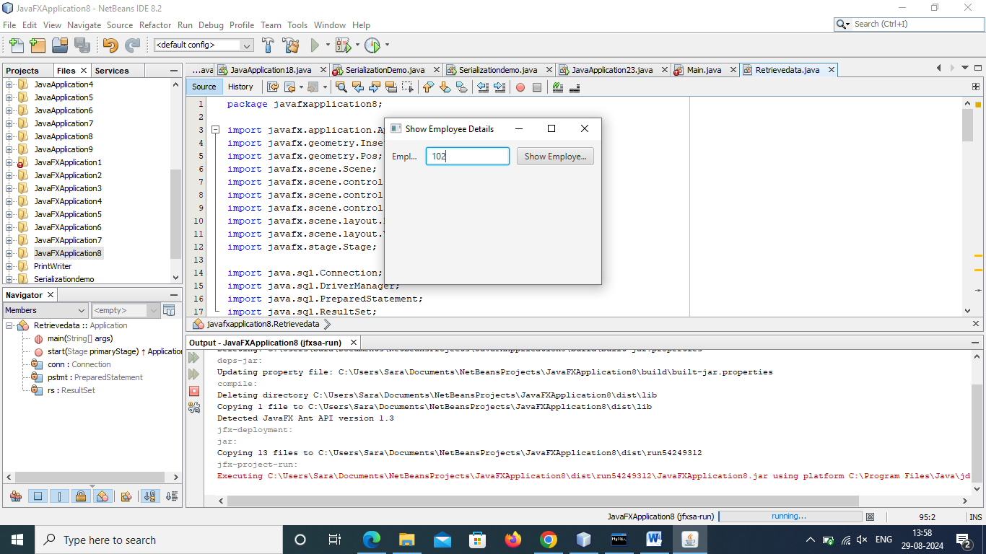

**Output:**

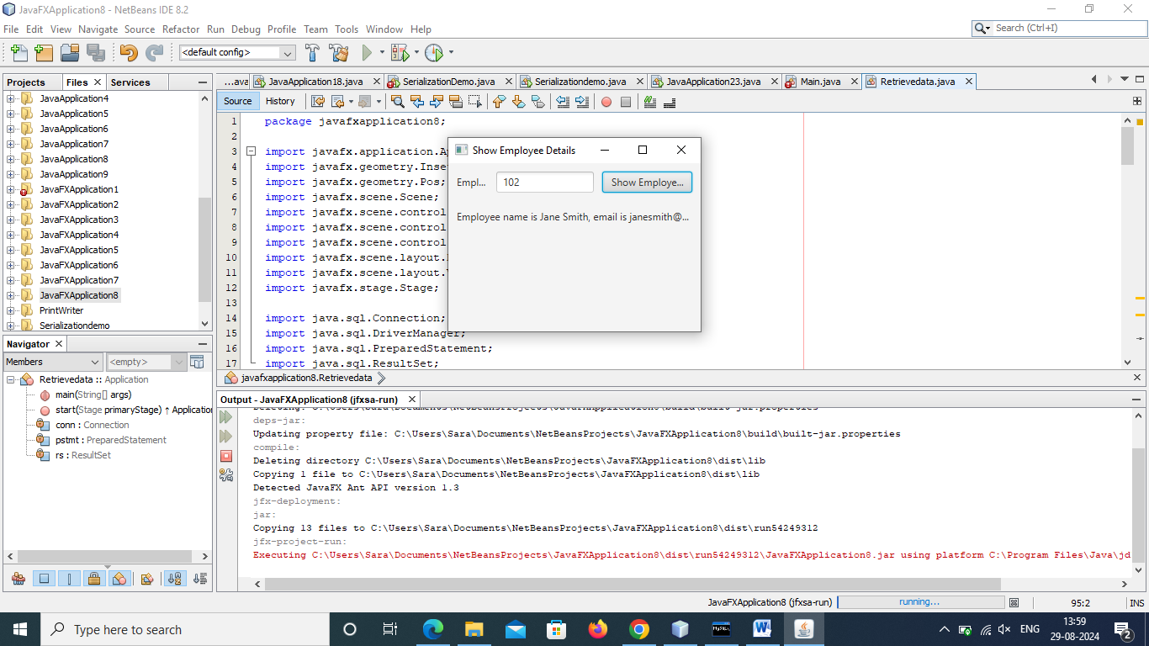

**2. Callable Statement:**

**Code:**

package javafxapplication9;

import javafx.application.Application;

import javafx.geometry.Insets;

import javafx.geometry.Pos;

import javafx.scene.Scene;

import javafx.scene.control.Button;

import javafx.scene.control.Label;

import javafx.scene.control.TextField;

import javafx.scene.layout.HBox;

import javafx.scene.layout.VBox;

import javafx.stage.Stage;

import java.sql.CallableStatement;

import java.sql.Connection;

import java.sql.DriverManager;

import java.sql.ResultSet;

import java.sql.SQLException;

public class Calleble_Statement extends Application {

private Connection conn;

private CallableStatement cstmt;

private ResultSet rs;

@Override

public void start(Stage primaryStage) {

HBox inputBox = new HBox(10);

inputBox.setAlignment(Pos.CENTER_RIGHT);

inputBox.setPadding(new Insets(10));

Label idLabel = new Label("Employee ID:");

TextField idField = new TextField();

Button searchButton = new Button("Search");

inputBox.getChildren().addAll(idLabel, idField, searchButton);

VBox outputBox = new VBox(10);

outputBox.setAlignment(Pos.CENTER);

outputBox.setPadding(new Insets(10));

Scene scene = new Scene(new VBox(inputBox, outputBox), 300, 200);

primaryStage.setScene(scene);

primaryStage.setTitle("Employee Search");

primaryStage.show();

searchButton.setOnAction(e -> {

String employeeIdStr = idField.getText();

if (!employeeIdStr.isEmpty()) {

try {

int employeeId = Integer.parseInt(employeeIdStr);

conn = DriverManager.getConnection("jdbc:mysql://localhost:3306/empdb", "root", "Sara@123");

cstmt = conn.prepareCall("{call getEmployeeDetails(?)}");

cstmt.setInt(1, employeeId);

rs = cstmt.executeQuery();

if (rs.next()) {

String fname = rs.getString("fname");

String lname = rs.getString("lname");

String gmailId = rs.getString("gmail_id");

Label detailsLabel = new Label("Employee Details:");

Label fnameLabel = new Label("First Name: " + fname);

Label lnameLabel = new Label("Last Name: " + lname);

Label gmailIdLabel = new Label("Gmail ID: " + gmailId);

outputBox.getChildren().addAll(detailsLabel, fnameLabel, lnameLabel, gmailIdLabel);

} else {

Label notFoundLabel = new Label("Employee not found!");

outputBox.getChildren().add(notFoundLabel);

}

} catch (SQLException ex) {

System.err.println("Error: " + ex.getMessage());

} finally {

try {

if (rs != null) rs.close();

if (cstmt != null) cstmt.close();

if (conn != null) conn.close();

} catch (SQLException ex) {

System.err.println("Error closing resources: " + ex.getMessage());

}

}

}

});

}

public static void main(String[] args) {

launch(Calleble_Statement.class, args);

}

}

**Input:**

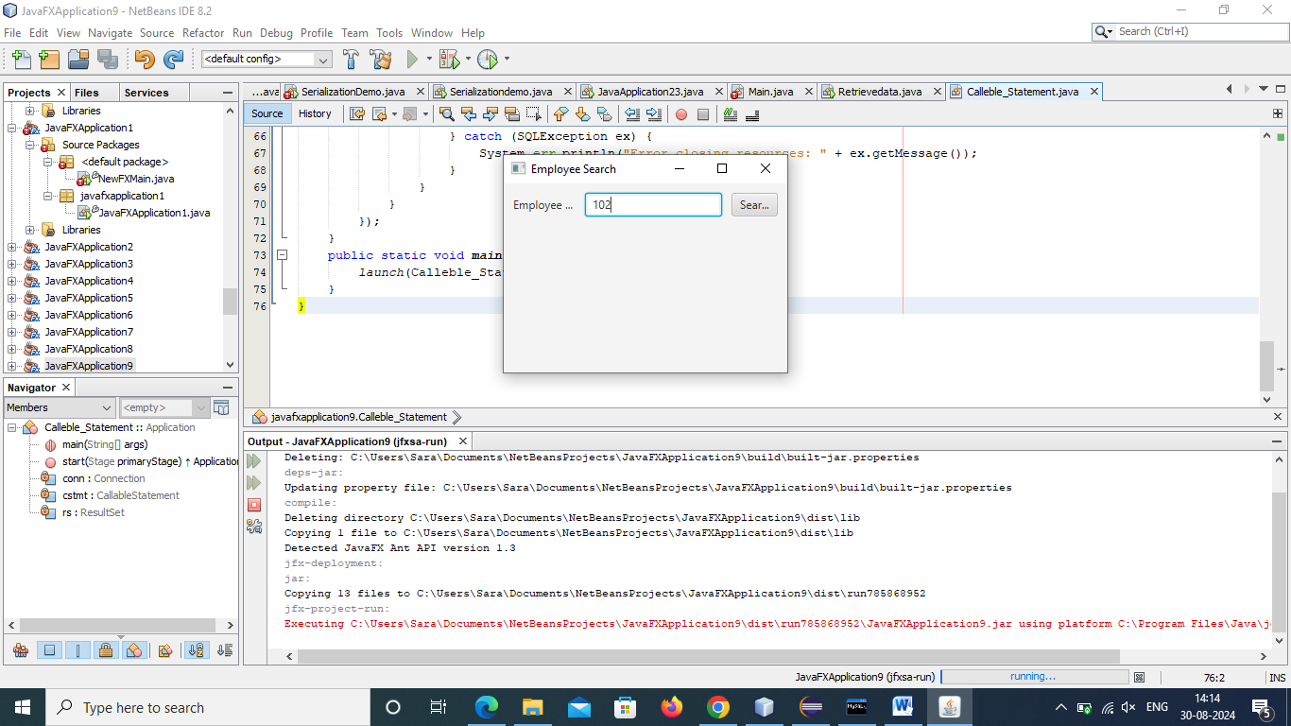

**Output:**

